Lab Manual

.NET

PRITESH SENGARA

160470107050

VVPEC CE Sem-6

Contents

Introduction to C# 1

GTUPrograms 9

Overloading 16

Reflection API 22

Perform File Handling. 25

Windows Form Application 30

ASP.NET Validation Control 33

Introduction to Master Pages. 35

**Practical 1**

AIM:

# Introduction to C#

using System;

using System.Collections.Generic;

using System.Linq;

using System.Text;

namespace Program1

{

class vector

{

public int value;

}

class Program1

{

static int i = 25;

public enum TimeOfDay

{

Morning = 0,

Afternoon = 1,

Evening = 2

}

static void Main(string[] args)

{

Console.WriteLine("This is first program");

//Scope of variables

int i=5;

Console.WriteLine("Scope of the variable {0}",i);

for (i = 0; i < 2; i++)

{

Console.WriteLine("{0} {1}",i,Program1.i);

}

for (int k = 0; k < 2; k++)

{

Console.WriteLine("{0}",k);

}

//Constant

const int valueConst=25;

Console.WriteLine("{0}",valueConst);

//valueConst = 15;

const int valueConst2 = 15;

Console.WriteLine("{0}", valueConst2);

//valueConst = valueConst2;

Console.WriteLine("{0}",valueConst);

//Value Type DataTypes

Console.WriteLine("Value Type");

int val1, val2;

val1 = 50;

Console.WriteLine("val1= {0}",val1);

val2 = val1;

Console.WriteLine("val1= {0} val2= {1}", val1,val2);

//Reference Type

Console.WriteLine("Reference Type");

vector x, y;

x = new vector();

x.value = 15;

y = x;

Console.WriteLine("x = {0} y = {1}", x.value,y.value);

y.value = 151;

Console.WriteLine("x = {0} y = {1}", x.value, y.value);

Console.WriteLine("\n Interger Types");

sbyte sb = 22;

short s = 22;

int i1 = 22;

long l = 22L;

Console.WriteLine("{0} sbtye\n{1} short\n{2} int\n{3} long\n",sb,s,i1,l);

Console.WriteLine("Unsigned Integers");

byte b = 21;

ushort us = 21;

uint ui = 21;

ulong ul = 21;

Console.WriteLine("{0} btye\n{1} ushort\n{2} uint\n{3} ulong\n", b, us, ui, ul);

Console.WriteLine("Floating Point");

float f = 11.22334455F;

double d = 11.2233445566778899;

Console.WriteLine("{0} float\n{1} double", f, d);

decimal dec = 111.222333444555666777888999M;

Console.WriteLine("Decimal:\n{0}", dec);

Console.WriteLine("\nBoolean:");

bool valBoolean = true;

Console.WriteLine("Status: " + valBoolean);

Console.WriteLine("\nCharacter:\nSingle Quote \'");

Console.WriteLine("Double Quote \"");

Console.WriteLine("Back Slash \\");

char charA = 'A';

Console.WriteLine(charA);

int integerA = 2;

Console.WriteLine("Predefined Reference Type");

Object o1 = "This is object 1";

Object o2 = 34;

String strObj = o1 as string;

Console.WriteLine(strObj);

Console.WriteLine(o1.GetHashCode() + " " + o1.GetType());

Console.WriteLine(o2.GetHashCode() + " " + o2.GetType());

Console.WriteLine(o1.Equals(o2));

string s1, s2;

s1 = "String 1";

s2 = s1;

Console.WriteLine("S1 is: {0} and s2 is {1}", s1, s2);

s2 = "New String 1";

Console.WriteLine("S1 is: {0} and s2 is {1}", s1, s2);

s1 = "c:\\NewFolder\\Hello\\P1.cs";

Console.WriteLine(s1);

s1 = @"c:\NewFolder\Hello\P1.cs";

Console.WriteLine(s1);

s1 = @"We can also write

like this";

Console.WriteLine(s1);

Console.WriteLine("Flow control if statement");

bool isZero;

Console.WriteLine("\nFlow Control: (if)\ni is " + i);

if (i == 0)

{

isZero = true;

Console.WriteLine("i is Zero");

}

else

{

isZero = false;

Console.WriteLine("i is Non - zero");

}

//else if

Console.WriteLine("\nType in a string:");

string input;

input = Console.ReadLine();

if (input == "")

{

Console.WriteLine("You typed in an empty string");

}

else if (input.Length < 5)

{

Console.WriteLine("The string had less than 5 characters");

}

else if (input.Length < 10)

{

Console.WriteLine("The string had at least 5 but less than 10 characters");

}

Console.WriteLine("The string was " + input);

Console.WriteLine("\nSwitch:");

switch (integerA)

{

case 1:

Console.WriteLine("integerA = 1");

break;

case 2:

Console.WriteLine("integerA = 2");

//goto case 3;

break;

case 3:

Console.WriteLine("integerA = 3");

break;

default:

Console.WriteLine("integerA is not 1, 2, or 3");

break;

}

WriteGreeting(TimeOfDay.Morning);

Console.WriteLine("Argument is: {0}", args[1]);

Console.ReadLine();

}

static void WriteGreeting(TimeOfDay timeOfDay)

{

switch (timeOfDay)

{

case TimeOfDay.Morning:

Console.WriteLine("Good morning!");

break;

case TimeOfDay.Afternoon:

Console.WriteLine("Good afternoon!");

break;

case TimeOfDay.Evening:

Console.WriteLine("Good evening!");

break;

default:

Console.WriteLine("Hello!");

break;

}

}

}

}

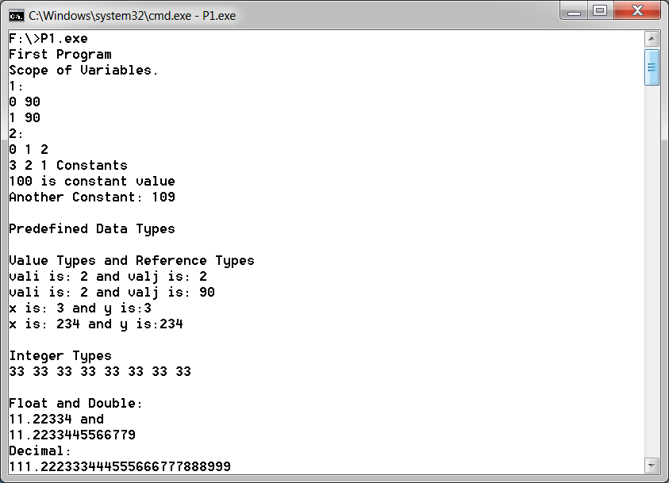

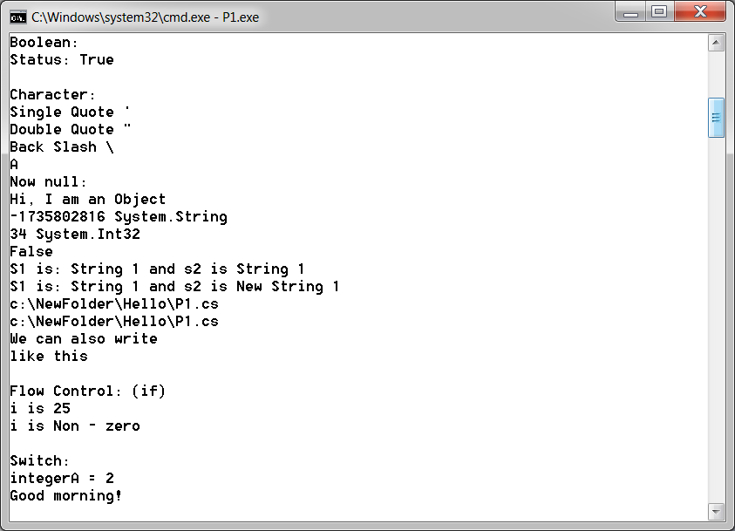

**Practical 2**

AIM:

# GTUPrograms

Program 1:

AIM: Write console based program in code behind language VB or C# to print following pattern.

@ @ @ @ @

@ @ @ @

@ @ @

@ @

@

using System;

using System.Collections.Generic;

using System.Linq;

using System.Text;

namespace Pattern1

{

class Program

{

static void Main(string[] args)

{

for (int i = 5; i > 0; i--)

{

for (int j = 0; j <i; j++)

{

Console.Write("@");

}

Console.WriteLine();

}

Console.ReadKey();

}

}

}

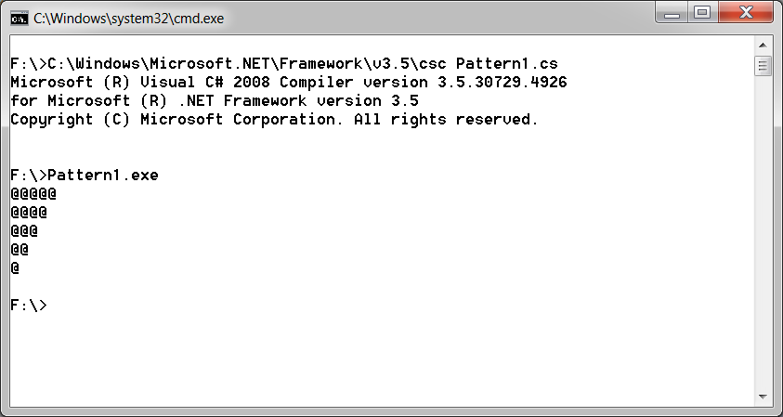

Program 2

AIM: Write console based program in code behind language VB or C# to print following pattern.

1

1 2

1 2 3

1 2 3 4

using System;

using System.Collections.Generic;

using System.Linq;

using System.Text;

namespace Pattern2

{

class Program

{

static void Main(string[] args)

{

String s = Console.ReadLine();

int value = int.Parse(s);

for (int i = 1; i <= value; i++)

{

for (int j = 1; j <=i; j++)

{

Console.Write("{0} ",j);

}

Console.WriteLine();

}

Console.ReadKey();

}

}

}

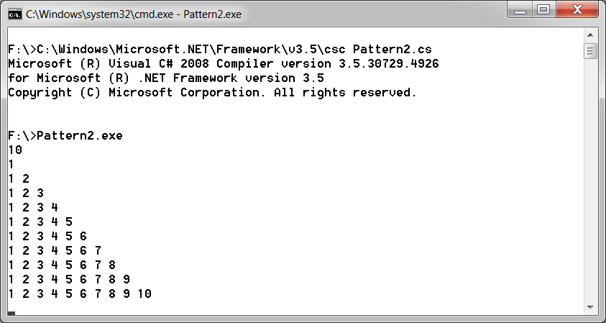

Program 3

AIM: Write C# code to prompt a user to input his/her name and country name and then the output will be shown as an example below:

Hello Ram from country India

using System;

using System.Collections.Generic;

using System.Linq;

using System.Text;

namespace PrintNameCountry

{

class Program

{

static void Main(string[] args)

{

Console.WriteLine("Enter name");

String name = Console.ReadLine();

Console.WriteLine("Enter Country");

String country = Console.ReadLine();

Console.WriteLine("Hello {0} from country {1}", name, country);

Console.ReadKey();

}

}

}

**Output:**

E:\>Country.exe

Enter name

Pritesh

Enter Country

India

Hello Pritesh from country India

E:\>

Program 4

AIM: Create C# console application to define Car class and derive Maruti and Mahindra from it to demonstrate inheritance.

using System;

using System.Collections.Generic;

using System.Linq;

using System.Text;

namespace Inheritance

{

class Car

{

protected String name, fuel,id;

}

class Maruti: Car

{

internal Maruti(String name, String fuel, String id)

{

this.name = name;

this.fuel = fuel;

this.id = id;

Console.WriteLine("{0} {1} {2}",this.name, this.fuel, this.id);

}

}

class Mahindra : Car

{

internal Mahindra(String name, String fuel, String id)

{

this.name = name;

this.fuel = fuel;

this.id = id;

Console.WriteLine("{0} {1} {2}",this.name, this.fuel, this.id);

}

}

class Program

{

static void Main(string[] args)

{

Maruti obj1= new Maruti("abc","petrol","123");

Mahindra obj2 =new Mahindra("pqr","disel","456");

Console.ReadKey();

}

}

}

**Output:**

E:\>Inheritence.exe

abc petrol 123

pqr diesel 456

E:\>

**Practical 3**

AIM:

# Overloading

1.Write a c# program to add two integers, two vectors and two metric using method overloading.

using System;

using System.Collections.Generic;

using System.Linq;

using System.Text;

namespace MethodOverloading

{

class Vector

{

internal int x, y, z;

internal Vector(int x, int y, int z)

{

this.x = x;

this.y = y;

this.z = z;

}

internal Vector() { }

}

class Matrix

{

internal int [,] m = new int[2,2];

internal Matrix(){}

}

class Program

{

static void add(int a, int b)

{

int temp = a + b;

Console.WriteLine(temp);

}

static void add(Vector a, Vector b)

{

Vector temp = new Vector();

temp.x = a.x + b.x;

temp.y = a.y + b.y;

temp.z = a.z + b.z;

Console.WriteLine("{0}x {1}y {2}z", temp.x, temp.y, temp.z);

}

static void add(Matrix a, Matrix b)

{

Matrix temp = new Matrix();

for (int i = 0; i < 2; i++)

{

for (int j = 0; j < 2; j++)

{

temp.m[i, j]=a.m[i,j]+b.m[i,j];

Console.Write(temp.m[i, j]+"\t");

}

Console.Write("\n");

Console.WriteLine();

}

}

static void Main(string[] args)

{

Console.WriteLine("Enter Vector");

Vector a = new Vector(int.Parse(Console.ReadLine()), int.Parse(Console.ReadLine()), int.Parse(Console.ReadLine()));

Vector b = new Vector(int.Parse(Console.ReadLine()), int.Parse(Console.ReadLine()), int.Parse(Console.ReadLine()));

add(a, b);

Console.WriteLine("Enter integer");

int x = int.Parse(Console.ReadLine());

int y = int.Parse(Console.ReadLine());

add(x, y);

Console.WriteLine("Sum of Matrix is\n");

Matrix m1 = new Matrix();

Matrix m2 = new Matrix();

m1.m[0, 0] = 2;

m1.m[0, 1] = 2;

m1.m[1, 0] = 2;

m1.m[1, 1] = 2;

m2.m[0, 0] = 3;

m2.m[0, 1] = 3;

m2.m[1, 0] = 3;

m2.m[1, 1] = 3;

add(m1, m2);

Console.ReadKey();

}

}

}

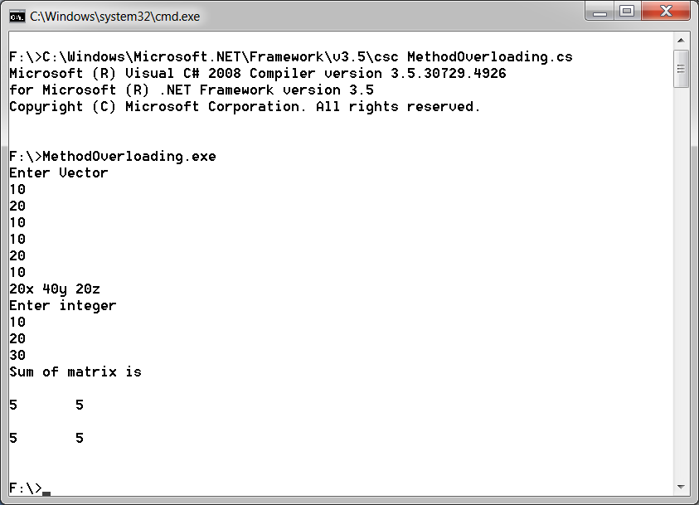

2. Write a c# program that create student object. Overload constror to create new instant with following details.

1. Name

2. Name, Enrollment

3. Name, Enrollment, Branch

using System;

using System.Collections.Generic;

using System.Linq;

using System.Text;

namespace ConstructorOverloading

{

class Student

{

String name,enroll_no,branch;

public Student(String name)

{

this.name = name;

}

public Student(String name, String enroll_no)

{

this.name = name;

this.enroll_no = enroll_no;

}

public Student(String name, String enroll_no, String branch)

{

this.name = name;

this.enroll_no = enroll_no;

this.branch = branch;

}

internal String getName()

{

return this.name;

}

internal String getEnroll()

{

return this.enroll_no;

}

internal String getBranch()

{

return this.branch;

}

}

class Program

{

static void Main(string[] args)

{

Student s1 = new Student("abc");

Console.WriteLine(s1.getName());

Student s2 = new Student("pqr", "16047010459");

Console.WriteLine(s2.getName());

Console.WriteLine(s2.getEnroll());

Student s3 = new Student("xyz", "1604710236", "computer");

Console.WriteLine(s3.getName());

Console.WriteLine(s3.getEnroll());

Console.WriteLine(s3.getBranch());

Console.ReadKey();

}

}

}

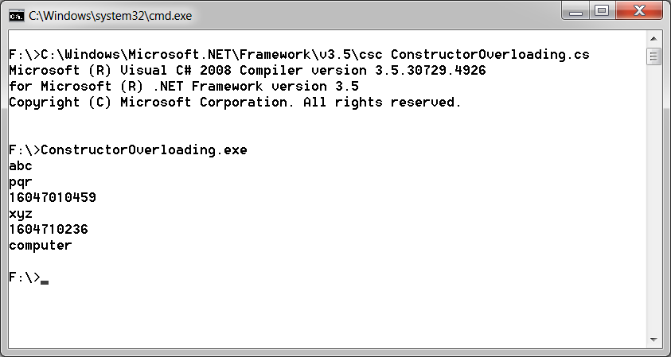

**Practical 4**

AIM:

# Reflection API

1. Create a c# program to find Methods, Properties and Constructors from class of running program.

using System;

using System.Collections.Generic;

using System.Linq;

using System.Text;

using System.Reflection;

namespace Reflection

{

class Student

{

String name, enroll_no, branch;

public Student(String name)

{

this.name = name;

}

public Student(String name, String enroll_no)

{

this.name = name;

this.enroll_no = enroll_no;

}

public Student(String name, String enroll_no, String branch)

{

this.name = name;

this.enroll_no = enroll_no;

this.branch = branch;

}

public String getName()

{

return this.name;

}

public String getEnroll()

{

return this.enroll_no;

}

public String getBranch()

{

return this.branch;

}

}

class Program

{

static void Main(string[] args)

{

Type t = Type.GetType("Reflection.Student");

ConstructorInfo[] ci = t.GetConstructors();

MethodInfo[] mi = t.GetMethods();

foreach (ConstructorInfo c in ci)

{

Console.WriteLine(c.ToString());

}

foreach (MethodInfo m in mi)

{

Console.WriteLine(m.ToString());

}

Console.ReadLine();

}

}

}

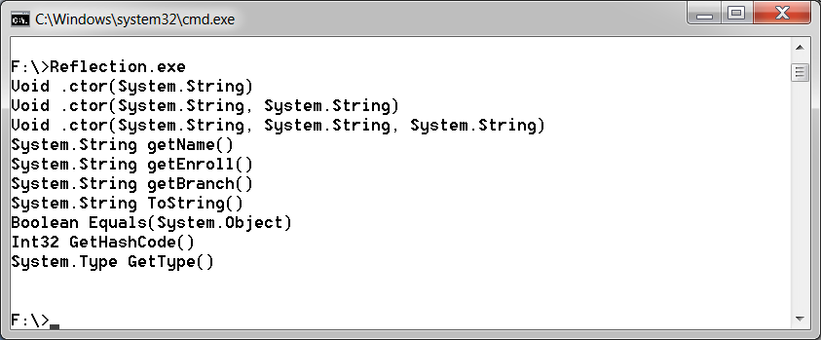

**Practical 5**

AIM:

# Perform File Handling.

1. Write a C# program to copy data from one file to another using StreamReader and StreamWriter class.

Program 1

using System;

using System.Collections.Generic;

using System.Linq;

using System.Text;

using System.IO;

namespace CopyFile1

{

class Program

{

static void Main(string[] args)

{

String file1 = @"F:\file1.txt";

String file2 = @"F:\file2.txt";

using (StreamReader reader = new StreamReader(file1))

{

using (StreamWriter writer = new StreamWriter(file2))

{

writer.Write(reader.ReadToEnd());

}

}

}

}

}

FILE1:

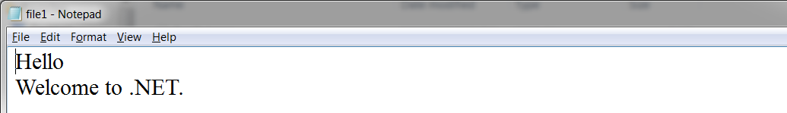

FILE2:



2. Write a C# Program to Read Lines from a File until the End of File is Reached.

Program 2

using System;

using System.Collections.Generic;

using System.Linq;

using System.Text;

using System.IO;

namespace CopyFile2

{

class Program

{

static void Main(string[] args)

{

String file1 = @"F:\file1.txt";

String file2 = @"F:\file2.txt";

String content = null;

using (StreamReader reader = new StreamReader(file1))

{

using (StreamWriter writer = new StreamWriter(file2))

{

while ((content = reader.ReadLine())!= null)

{

writer.WriteLine(content);

}

}

}

}

}

}

FILE1:

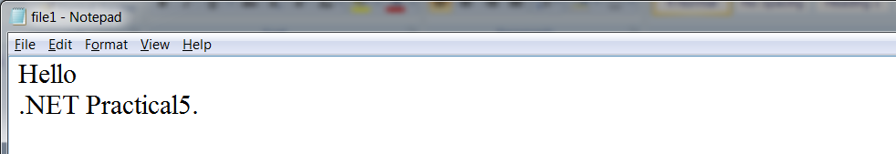

FILE3:

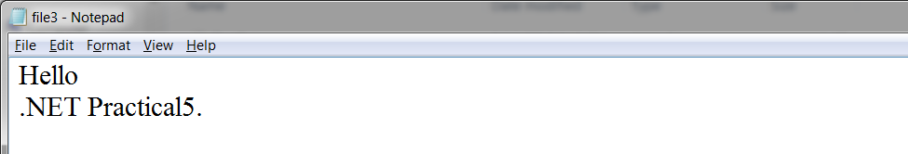

3. Write a C# Program to List Files in a Directory.

Program 3

using System;

using System.Collections.Generic;

using System.Linq;

using System.Text;

using System.IO;

namespace filepractical3

{

class Program

{

static void Main(string[] args)

{

String[] Directories = Directory.GetDirectories(@"F:\DotNET");

foreach (string dir in Directories)

Console.WriteLine(dir);

Console.WriteLine("files are :");

String[] files = Directory.GetFiles(@"F:\DotNET");

foreach (string file in files)

Console.WriteLine(file);

Console.ReadKey();

}}}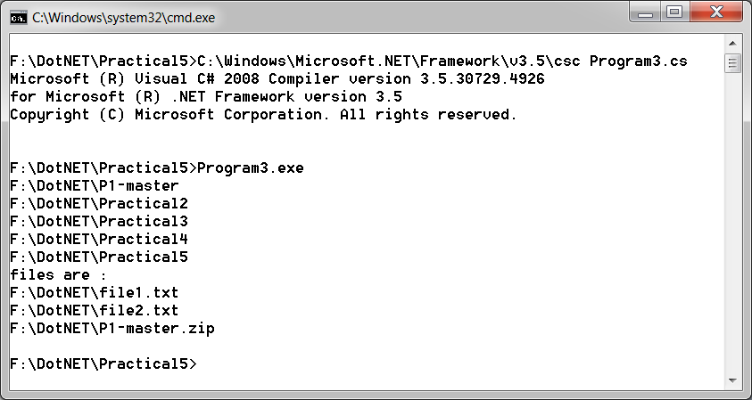

**Practical 6**

AIM:

# Windows Form Application

1.Create Windows Form Application for Student Registration and store student Details in DataBase.

using System;

using System.Collections.Generic;

using System.ComponentModel;

using System.Data;

using System.Drawing;

using System.Linq;

using System.Text;

using System.Windows.Forms;

using System.Data.SqlClient;

using System.IO;

namespace WindowsForm1

{

public partial class Form1 : Form

{

string imgPath; public String gender;

public Form1()

{

InitializeComponent();

}

private void Form1_Load(object sender, EventArgs e)

{

}

private void button1_Click(object sender, EventArgs e)

{

String source = @"Data Source=CE3COMP3\sqlexpress;Initial Catalog=DBstudent;Integrated Security=True;Pooling=False";

SqlConnection con = new SqlConnection(source);

con.Open();

String ins = "insert into Tbl1(fname,Middlename,Lname,gender,Date) values('"+fname.Text+"','"+ Middlename.Text+ "','" + Lname.Text + "','" +gender+"','"+ dateTimePicker1.Value.Date +"')";

SqlCommand sc = new SqlCommand(ins, con);

int i=sc.ExecuteNonQuery();

if (i > -1)

{

MessageBox.Show("Entered into database");

}

}

private void button3_Click(object sender, EventArgs e)

{

openFileDialog1.Filter = "Png|*.png";

if (openFileDialog1.ShowDialog() == DialogResult.OK)

{

imgPath = @"C:\Users\CRP\Desktop\Images\"+ openFileDialog1.SafeFileName;

pictureBox.Image = Image.FromFile(openFileDialog1.FileName);

}

}

private void Male_CheckedChanged(object sender, EventArgs e)

{

if (Male.Checked)

{

gender = "Male";

}

else

{

gender = "Female";

}

}

}

}

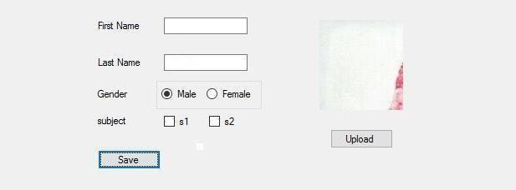

**Practical 7**

AIM:

# ASP.NET Validation Control

RequiredFieldValidator

CompareValidator

RegularExpressionValidator

CustomValidator

RangeValidator

ValidationSummary

Top of Form

<%@ Page Language="C#" AutoEventWireup="true" CodeBehind="WebForm1.aspx.cs" Inherits="ASPWebApplication1.WebForm1" %>

<!DOCTYPE html PUBLIC "-//W3C//DTD XHTML 1.0 Transitional//EN" "http://www.w3.org/TR/xhtml1/DTD/xhtml1-transitional.dtd">

<html xmlns="http://www.w3.org/1999/xhtml">

<head runat="server">

<title></title>

</head>

<body>

<form id="form1" runat="server">

<div>

</div>

name

<asp:TextBox ID="Txtname" runat="server"></asp:TextBox>

<asp:RequiredFieldValidator ID="RequiredFieldValidator1" runat="server"

ControlToValidate="Txtname" ErrorMessage="name is required" ForeColor="Red"

ToolTip="Please enter name">*</asp:RequiredFieldValidator>

<br />

&nbsp;

<br />

email<asp:TextBox ID="Txtemail" runat="server"

ontextchanged="TextBox1_TextChanged"></asp:TextBox>

<asp:RegularExpressionValidator ID="RegularExpressionValidator1" runat="server"

ControlToValidate="Txtemail" ErrorMessage="not valid email address"

ForeColor="Red" ToolTip="enter valid email"

ValidationExpression="\w+([-+.']\w+)[*@\w+([-.]\w+)*\.\w+([-](mailto:*@\w+(%5b-.%5d\w+)*\.\w+(%5b-).]\w+)*">*</asp:RegularExpressionValidator>

<br />

<br />

phone no<asp:TextBox ID="Txtphone" runat="server"

ontextchanged="Txtphone_TextChanged"></asp:TextBox>

<asp:RegularExpressionValidator ID="RegularExpressionValidator2" runat="server" ControlToValidate="Txtphone" ErrorMessage="not valid phone no" ForeColor="Red" ToolTip="enter 10 digit mobile no" ValidationExpression="[0-9]{10}">*</asp:RegularExpressionValidator>

<br />

<br />

password<asp:TextBox ID="Txtpassword" runat="server"></asp:TextBox>

<br />

<br />

confirm password<asp:TextBox ID="Txtcpasswoed" runat="server"></asp:TextBox>

<asp:CompareValidator ID="CompareValidator1" runat="server"

ControlToCompare="Txtpassword" ControlToValidate="Txtcpasswoed"

ErrorMessage="confirm password not same as passord"

ToolTip="not same as password" Type="Integer"></asp:CompareValidator>

<br />

<br />

sem<asp:TextBox ID="Txtsem" runat="server"></asp:TextBox>

<asp:RangeValidator ID="RangeValidator1" runat="server"

ControlToValidate="Txtsem" ErrorMessage="not valid semester" MaximumValue="8"

MinimumValue="1"></asp:RangeValidator>

<br />

<asp:Button ID="Button1" runat="server" onclick="Button1_Click" Text="submit"/>

<br />

<asp:ValidationSummary ID="ValidationSummary1" runat="server" />

</form>

</body>

</html>

OUTPUT:

# 

**Practical 8**

AIM:

# Introduction to Master Pages.

**Site1.Master**

<%@ Master Language="C#" AutoEventWireup="true" CodeBehind="Site1.master.cs" Inherits="ASPApplication2.Site1" %>

<!DOCTYPE html PUBLIC "-//W3C//DTD XHTML 1.0 Transitional//EN" "http://www.w3.org/TR/xhtml1/DTD/xhtml1-transitional.dtd">

<html xmlns="http://www.w3.org/1999/xhtml">

<head runat="server">

<title></title>

<asp:ContentPlaceHolder ID="head" runat="server">

</asp:ContentPlaceHolder>

</head>

<body>

<form id="form1" runat="server">

<table>

<tr> <td>

<asp:Label ID="lblheader" runat="server" Text="header"></asp:Label></td></tr>

<tr>

<td>

<asp:Button ID="Buttonsearch" runat="server" Text="Button" />

<asp:ContentPlaceHolder ID="ContentPlaceHolder1" runat="server">

</asp:ContentPlaceHolder>

</td>

</tr>

<tr><td>footer</td></tr>

</table>

</form>

</body>

</html>

**Site1.Master.cs**

using System;

using System.Collections.Generic;

using System.Linq;

using System.Web;

using System.Web.UI;

using System.Web.UI.WebControls;

namespace ASPApplication2

{

public partial class Site1 : System.Web.UI.MasterPage

{

protected void Page_Load(object sender, EventArgs e)

{

}

public Label LblHeader

{

get { return lblheader; }

}

public Button buttonsearch

{

get { return Buttonsearch; }

}

}

}

**WebForm1.aspx**

<%@ Page Title="" Language="C#" MasterPageFile="~/Site1.Master" AutoEventWireup="true" CodeBehind="WebForm1.aspx.cs" Inherits="ASPApplication2.WebForm1" %>

<asp:Content ID="Content1" ContentPlaceHolderID="head" runat="server">

</asp:Content>

<asp:Content ID="Content2" ContentPlaceHolderID="ContentPlaceHolder1" runat="server">

<asp:TextBox ID="txtHeader" runat="server"></asp:TextBox>

<asp:Button ID="btn1" runat="server" Text="button"

onclick="Button1_Click" />

</asp:Content>

**WebForm1.aspx.cs**

using System;

using System.Collections.Generic;

using System.Linq;

using System.Web;

using System.Web.UI;

using System.Web.UI.WebControls;

namespace ASPApplication2

{

public partial class WebForm1 : System.Web.UI.Page

{

protected void Page_Load(object sender, EventArgs e)

{

}

protected void Button1_Click(object sender, EventArgs e)

{

((Site1)Master).LblHeader.Text = txtHeader.Text;

}

}

}

OUTPUT:

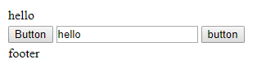

**WebForm2.aspx**

<%@ Page Title="" Language="C#" MasterPageFile="~/Site1.Master" AutoEventWireup="true" CodeBehind="WebForm2.aspx.cs" Inherits="ASPApplication2.WebForm2" %>

<asp:Content ID="Content1" ContentPlaceHolderID="head" runat="server">

</asp:Content>

<asp:Content ID="Content2" ContentPlaceHolderID="ContentPlaceHolder1" runat="server">

<asp:GridView ID="getdetails" runat="server">

</asp:GridView>

</asp:Content>

**WebForm2.aspx.cs**

using System;

using System.Collections.Generic;

using System.Linq;

using System.Web;

using System.Web.UI;

using System.Web.UI.WebControls;

using System.Data.SqlClient;

namespace ASPApplication2

{

public partial class WebForm2 : System.Web.UI.Page

{

protected void Page_Init(object sender, EventArgs e)

{

((Site1)Master).buttonsearch.Click+=new EventHandler(buttonsearch_Click);

}

void buttonsearch_Click(object sender, EventArgs e)

{

getData();

}

protected void Page_Load(object sender, EventArgs e)

{

}

void getData()

{

string source = @"Data Source=CE3COMP3\sqlexpress;Initial Catalog=DBstudent;Integrated Security=True;Pooling=False";

string select = "select * from Tbl1";

SqlConnection conn = new SqlConnection(source);

SqlCommand cmd = new SqlCommand(select,conn);

conn.Open();

SqlDataReader reader = cmd.ExecuteReader();

getdetails.DataSource = reader;

getdetails.DataBind();

conn.Close();

}

}

}

OUTPUT:

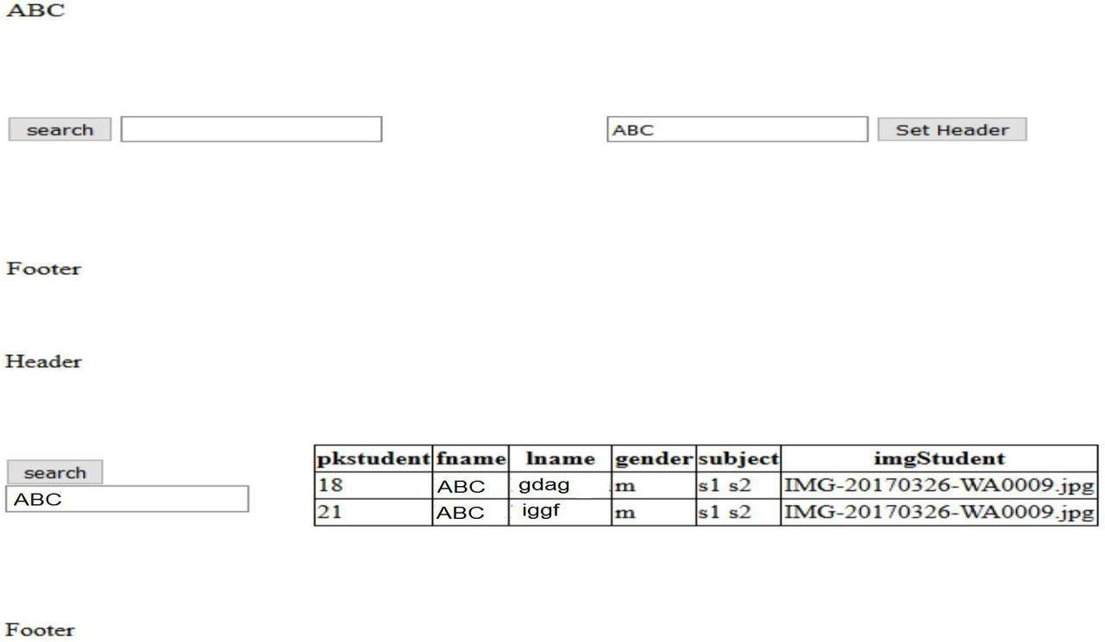

**Practical 9**

AIM:

# Create Web Service of calculator and consume it.

**WebService1.asmx.cs:**

|  |
| --- |
| using System.Linq; |
| using System.Web; |
| using System.Web.Services; |
|  |
| namespace WebApplication6 |
| { |
| /// <summary> |
| /// Summary description for WebService1 |
| /// </summary> |
| [WebService(Namespace = "http://tempuri.org/")] |
| [WebServiceBinding(ConformsTo = WsiProfiles.BasicProfile1_1)] |
| [System.ComponentModel.ToolboxItem(false)] |
| // To allow this Web Service to be called from script, using ASP.NET AJAX, uncomment the following line. |
| // [System.Web.Script.Services.ScriptService] |
| public class WebService1 : System.Web.Services.WebService |
| { |
| [WebMethod] |
| public string HelloWorld() |
| { |
| return "Hello World"; |
| } |
|  |
| [WebMethod] |
| public int Add( int a , int b ) |
| { |
| return a + b; |
| } |
|  |
| [WebMethod] |
| public int Sub(int a, int b) |
| { |
| return a - b; |
| } |
|  |
| [WebMethod] |
| public int Mul(int a, int b) |
| { |
| return a * b; |
| } |
|  |
| [WebMethod] |
| public int Div(int a, int b) |
| { |
| return a / b; |
| } |
|  |
| } |
| } |

**WebService1.aspx:**

|  |
| --- |
| <%@ Page Title="" Language="C#" MasterPageFile="~/Site1.Master" AutoEventWireup="true" CodeBehind="WebForm1.aspx.cs" Inherits="WebApplication6.WebForm1" %> |
| <asp:Content ID="Content1" ContentPlaceHolderID="head" runat="server"> |
| </asp:Content> |
| <asp:Content ID="Content2" ContentPlaceHolderID="ContentPlaceHolder1" runat="server"> |
| <asp:Label ID="lblA" runat="server" Height="20px" style="text-align: center" |
| Text="A" Width="130px"></asp:Label> |
| <br /> |
| <asp:TextBox ID="txtBoxA" runat="server" ontextchanged="TextBox1_TextChanged"></asp:TextBox> |
| <asp:RequiredFieldValidator ID="RequiredFieldValidator1" runat="server" |
| ErrorMessage="RequiredFieldValidator" ControlToValidate="txtBoxA">abc</asp:RequiredFieldValidator> |
| <br /> |
| <asp:Label ID="lblB" runat="server" Height="20px" style="text-align: center" |
| Text="B" Width="126px"></asp:Label> |
| <br /> |
| <asp:TextBox ID="txtBoxB" runat="server" ontextchanged="TextBox2_TextChanged"></asp:TextBox> |
| <asp:RequiredFieldValidator ID="RequiredFieldValidator2" runat="server" |
| ErrorMessage="RequiredFieldValidator" ControlToValidate="txtBoxB">abc</asp:RequiredFieldValidator> |
| <p> |
| <asp:Button ID="btnAdd" runat="server" onclick="btnAdd_Click" Text="+" /> |
| <asp:Button ID="btnSub" runat="server" Text="-" onclick="btnSub_Click" |
| style="width: 18px" /> |
| <asp:Button ID="btnMul" runat="server" Text="*" onclick="btnMul_Click" /> |
| <asp:Button ID="btnDiv" runat="server" onclick="Button4_Click" Text="/" /> |
| </p> |
| <p> |
| <asp:Label ID="lblResult" runat="server" Text="Result"></asp:Label> |
| </p> |
| </asp:Content> |

**WebService1.aspx.cs:**

|  |
| --- |
| using System; |
| using System.Collections.Generic; |
| using System.Linq; |
| using System.Web; |
| using System.Web.UI; |
| using System.Web.UI.WebControls; |
|  |
| namespace WebApplication6 |
| { |
| public partial class WebForm1 : System.Web.UI.Page |
| { |
| WebService1 calc = new WebService1(); |
|  |
| protected void Page_Load(object sender, EventArgs e) |
| { |
|  |
| } |
|  |
| protected void TextBox2_TextChanged(object sender, EventArgs e) |
| { |
|  |
| } |
|  |
| protected void TextBox1_TextChanged(object sender, EventArgs e) |
| { |
|  |
| } |
|  |
| protected void Button4_Click(object sender, EventArgs e) |
| { |
|  |
| } |
|  |
| protected void btnAdd_Click(object sender, EventArgs e) |
| { |
| lblResult.Text = calc.Add(Convert.ToInt16(txtBoxA.Text), Convert.ToInt16(txtBoxB.Text)).ToString(); |
| } |
| protected void btnSub_Click(object sender, EventArgs e) |
| lblResult.Text = calc.Sub(Convert.ToInt16(txtBoxA.Text), Convert.ToInt16(txtBoxB.Text)).ToString(); |
| } |
|  |
| protected void btnMul_Click(object sender, EventArgs e) |
| { |
| lblResult.Text = calc.Mul(Convert.ToInt16(txtBoxA.Text), Convert.ToInt16(txtBoxB.Text)).ToString(); |
| } |
|  |
| protected void btnDiv_Click(object sender, EventArgs e) |
| { |
| lblResult.Text = calc.Div(Convert.ToInt16(txtBoxA.Text), Convert.ToInt16(txtBoxB.Text)).ToString(); |
| } |
|  |
| } |
| } |

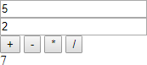OUTPUT: